Cost Breakdown for WISE Connections

- Securing Domain name
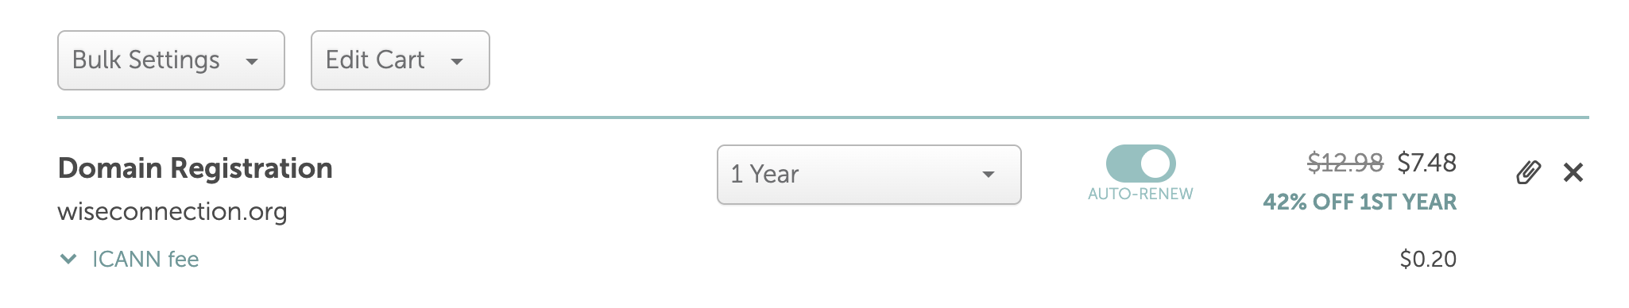

- Setting up Professional Email
- X10 costly, so waiting on wiseconnections@gmail.com
- Might have it as a plan for 5/10 years when we scale more.
- Launching through
- Can host through GitHub for free.

Conclusion:
The only cost will be around $15ish per year.

